**Visualizing Survey Data with Tableau**

Activity Guide

A demo of what we will make can be found here: <https://public.tableau.com/views/SurveyDataExample/Vote?:embed=y&:display_count=yes>

Download the data set: SurveySampleData_July2014C.xlsx

Open Tableau

Connect to Excel File > SurveySampleData_July2014C.xlsx

**Extract 1**

Drag the **Data_Labels** sheet to the “Drag Sheets Here” section of the interface

Drag the **Demographics** sheet to the same section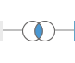

Select the Venn diagram symbol between the two sheets

Select Left Join on RespID



Click to highlight Columns Q0 through Q134e (hold down Shift key to highlight multiple columns at once)

Right click anywhere in the grey area and select “Pivot” from the dropdown menu. This will restructure your data so that the responses to non-demographic questions are in 2 columns.

Rename “Pivot Field Names” to “QuestionID” and “Pivot Field Values” to “Text Response”



Select Extract in the top right corner of the interface

Click the Sheet 1 tab and save the extract

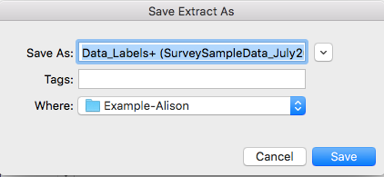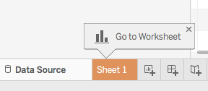

**Extract 2**

Select “New Data Source” from the “Data” dropdown menu in the toolbar

Connect to the same Excel File > SurveySampleData_July2014C.xlsx

Drag the **Data_Numbers** sheet to the “Drag Sheets Here” section of the interface

Click to highlight Columns Q0 through Q134e (hold down Shift key to highlight multiple columns at once)

Right click anywhere in the grey area and select “Pivot” from the dropdown menu.

Rename the “Pivot Field Names” column to “QuestionID” and “Pivot Field Values” to “Number Response”

Select Extract in the top right corner of the interface

Click the Sheet 1 tab and save the extract

**Extract 3**

Select “New Data Source” from the “Data” dropdown menu in the toolbar

Connect to Excel File > SurveySampleData_July2014C.xlsx

Drag the **Question Helper** sheet to the “Drag Sheets Here” section of the interface

Select Extract in the top right corner of the interface

Click the Sheet 1 tab and save the extract

**Join Extracted Data**

Select “New Data Source” from the “Data” dropdown menu in the toolbar

Select “More…” from the new data source dropdown menu

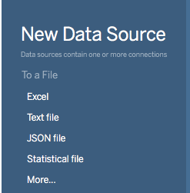

Connect to file > Data_Labels+Demog(SurveySampleData_July2014C).tde

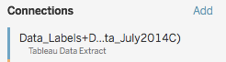

Select Add

Connect to file > Data_Numbers(SurveySampleData_July2014C).tde

Select the Venn diagram symbol between the two sources.

Join the sources: RespID = RespID (Extract 1)

QuestionID = Pivot Field Names (Extract 1)

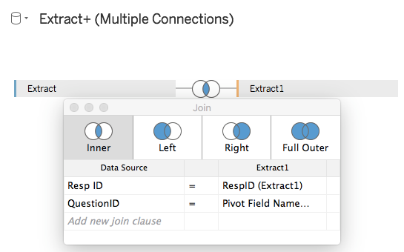

Add another source

Select “More…” from the new data source dropdown menu

Connect to file > Question Helper(SurveySampleData_July2014C).tde

Select the Venn diagram symbol between the two sources.

Join the sources: QuestionID = QuestionID

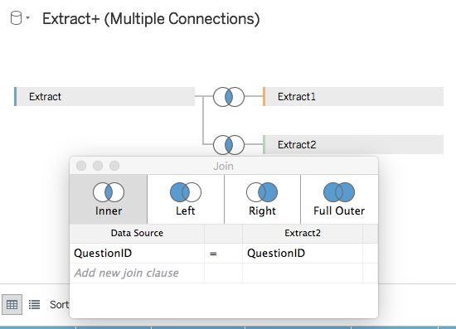

**Hide** Columns: Resp ID (Demographics), RespID (Extract 1), Pivot Field Names (Extract 1), Question ID (Question Helper)

Rename Column “Pivot Field Values” to “Number Response”

**Click on Sheet 1 to start exploring.**



Select the dropdown menu next to the Dimensions pane.

Select Group by Folder

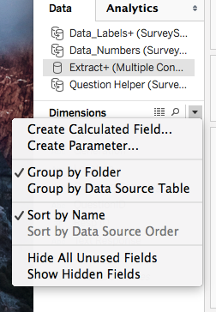

**Visualizing Yes/No/Maybe Data**

We’ll create a visualization that visualizes respondents’ answers to the “Will you vote in the upcoming election?” question. We will examine the data by the generation of respondents. This visualization is a bar chart that shows percentages of various categories.

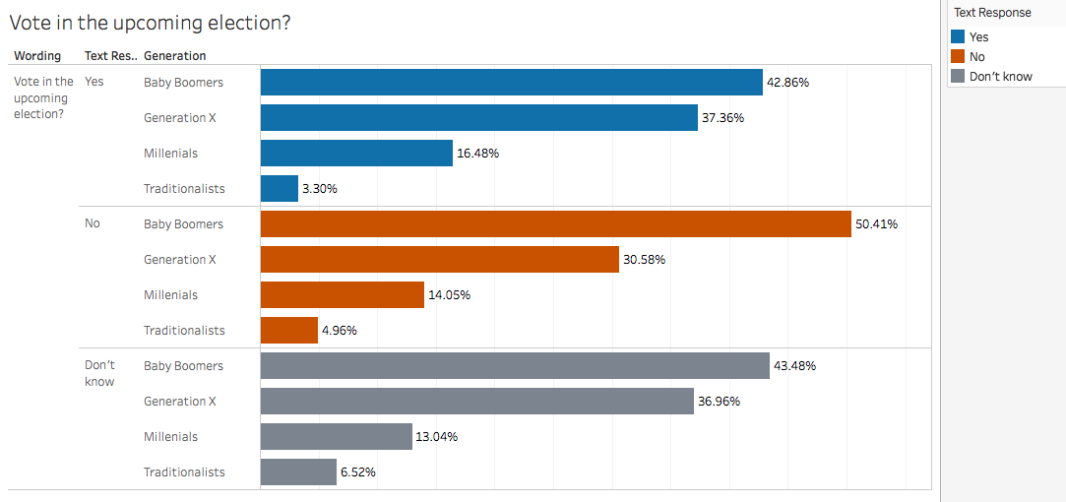

**I. Create a Filter to include ONLY the voting question.**

Drag Wording to filters. Click on Vote in the upcoming election? Click OK

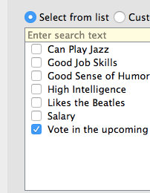

**II. Create a Bar Chart Showing Responses by Generation**

Drag Wording to Rows

Drag Text Response to Rows

Drag RespID to Columns

Click on RespID. Select Measure… choose Count (distinct)

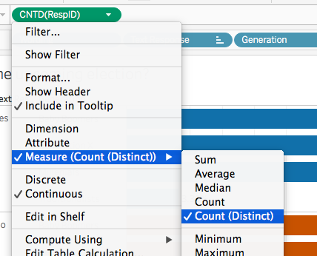

Click on RespID. From dropdown, select Quick Table Calculation… select **Percent of Total**

Drag Generation to Rows

Click on RespID again. From dropdown, select Compute by… choose **Pane (down)**

Drag RespID from Columns to Measures data pane to create a calculated field to use later.

Screen Shot 2017-02-07 at 3.38.47 PM.png

Drag Text Response to Color button on the Marks Card

*From the pop-up warning, select ‘Add all members’

Drag Text Response from Dimensions to Rows

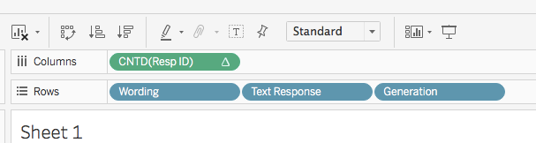

Drag RespID Calculated Field on the to Label button on the Marks card.

Exclude the Null values by filtering Text Responses on the right. 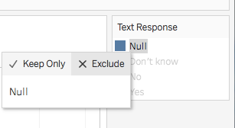

**Visualizing Likert Scale Data**

Click the icon to add a new sheet

**I. Create Filter that excludes all non-Likert questions**

Drag Question Grouping to Filter

Edit Filter

Select “Indicate degree to which you agree” - this will filter out all non-likert scale questions

**II. Create a Bar Chart**

Drag Wording to Rows

Drag RespID to Columns

Click RespID dropdown menu. Change from Measure (Sum) to Count (Distinct)

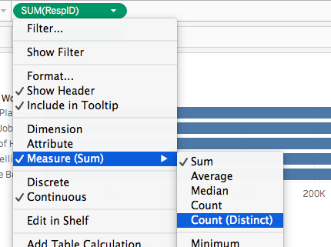

From the Same dropdown menu, select “Quick Table Calculation”. Select “Percent of Total”

Drag Text Response to Color

**III. Remove Null Values**

Click the blue Text Response pill in the Marks Card. Select Edit Filter.

**Unselect** Null from the list to exclude the Null values

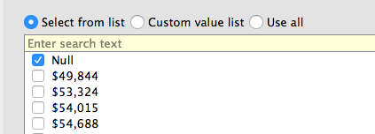

**IV. Manually Re-Sort the Values of the Legend**

Click on the dropdown arrow at the top right of the legend. Select Sort...

Select Manual. Re-order the values using Up and Down buttons.

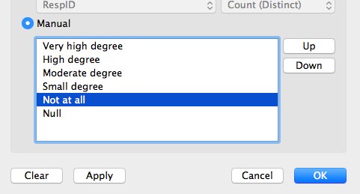

**V. Create a calculated field of average numeric responses for each question**

Click the Number Response variable under Measures

Using the dropdown for this variable, select Create Calculated Field...

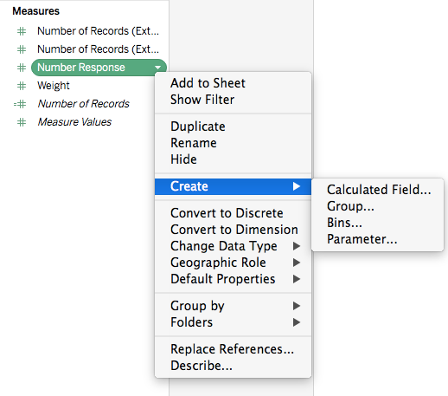

Name this field “Likert Avg”

Type the following formula:

AVG([Number Response]). Save it

**VI. Add averages to the chart as circles**

Remove Text Response from the Marks Card (Click dropdown and select “Remove”)

Drag your calculated field, “Likert Avg” to the Columns shelf

Click on AGG(Likert Avg) in Marks card to make it active.

Remove Text Response field.

Select “Circle” from dropdown menu

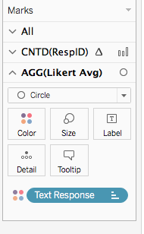

Click on CNTD(RespID) in Marks Card. It will pop up when it’s active.

Select the Bar option from the dropdown menu.

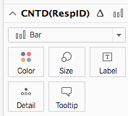

**VII. Create a Dual Axis so average bubbles are on top of bars**

Click “Likert Avg” dropdown menu in the Columns shelf. Select “Dual Axis”

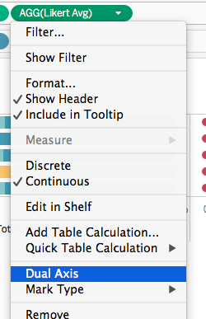

**VIII. Style the chart**

Adjust size so that the circles are large and gray.

Screen Shot 2017-02-08 at 3.10.14 PM.png

Add Label by clicking Label button and checking the “Show Mark Labels” box

Under Alignment, select the Center alignment icon under Horizontal

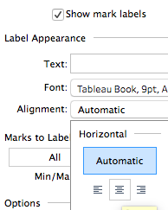

Adjust top axis range to the Fixed range of 0 to 4

Right click on top axis. Select Edit Axis...

Select Fixed End

Type 4 into the window under Fixed End. Click OK.

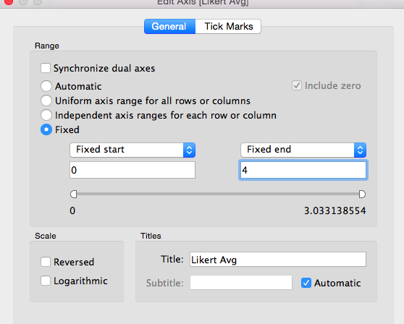

Re-order the bars by clicking the ordering icon: Screen Shot 2017-02-08 at 3.18.44 PM.png

Hide the top axis for cleaner appearance. Edit Axis… Show Header (clicking this will un-check it)

**IX. Change the number of decimal places of the averages**

From top menu, select Analysis

Select Table Layout…

Select Advanced

Under Default Number Format, select Manual

Change number of Decimal places to 1

Screen Shot 2017-02-08 at 3.28.50 PM.png

The numbers should now only have one decimal place:

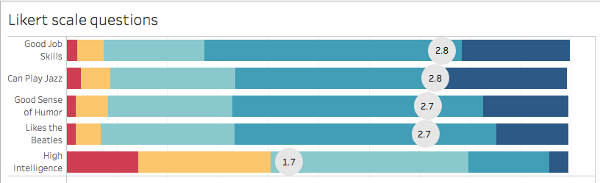

To examine the scales by Location, drag Location to the Columns shelf.

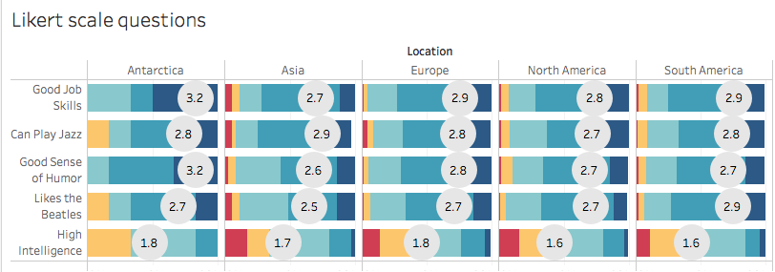

You’re done! Save the workbook as a .twbx file for sharing purposes!